User Stories

1. User stories for the current iteration (iteration 1):

In this iteration, we are focusing on the framework, the essential features for the user.

As a user, after installing this application, I want to have authorization with social media accounts, so that I can ensure my security and my comfort using the Inner Circle application.

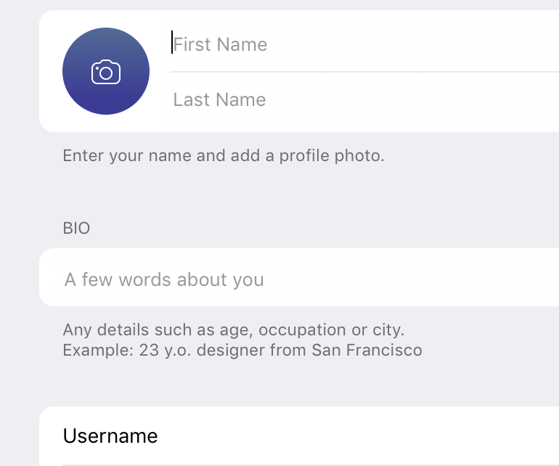

After I log in with my Google accounts, I want to update my profile, which includes my user name, my photo, my bio, and my contact information. The edit page will look like the interface showed the right side:

Then I would like to add some new friends, so I click the “+” sign and scan the QR code of my friends.

As a user, I should be able to start a new conversation by being able to initiate a new chat window with a new friend using the Inner Circle application

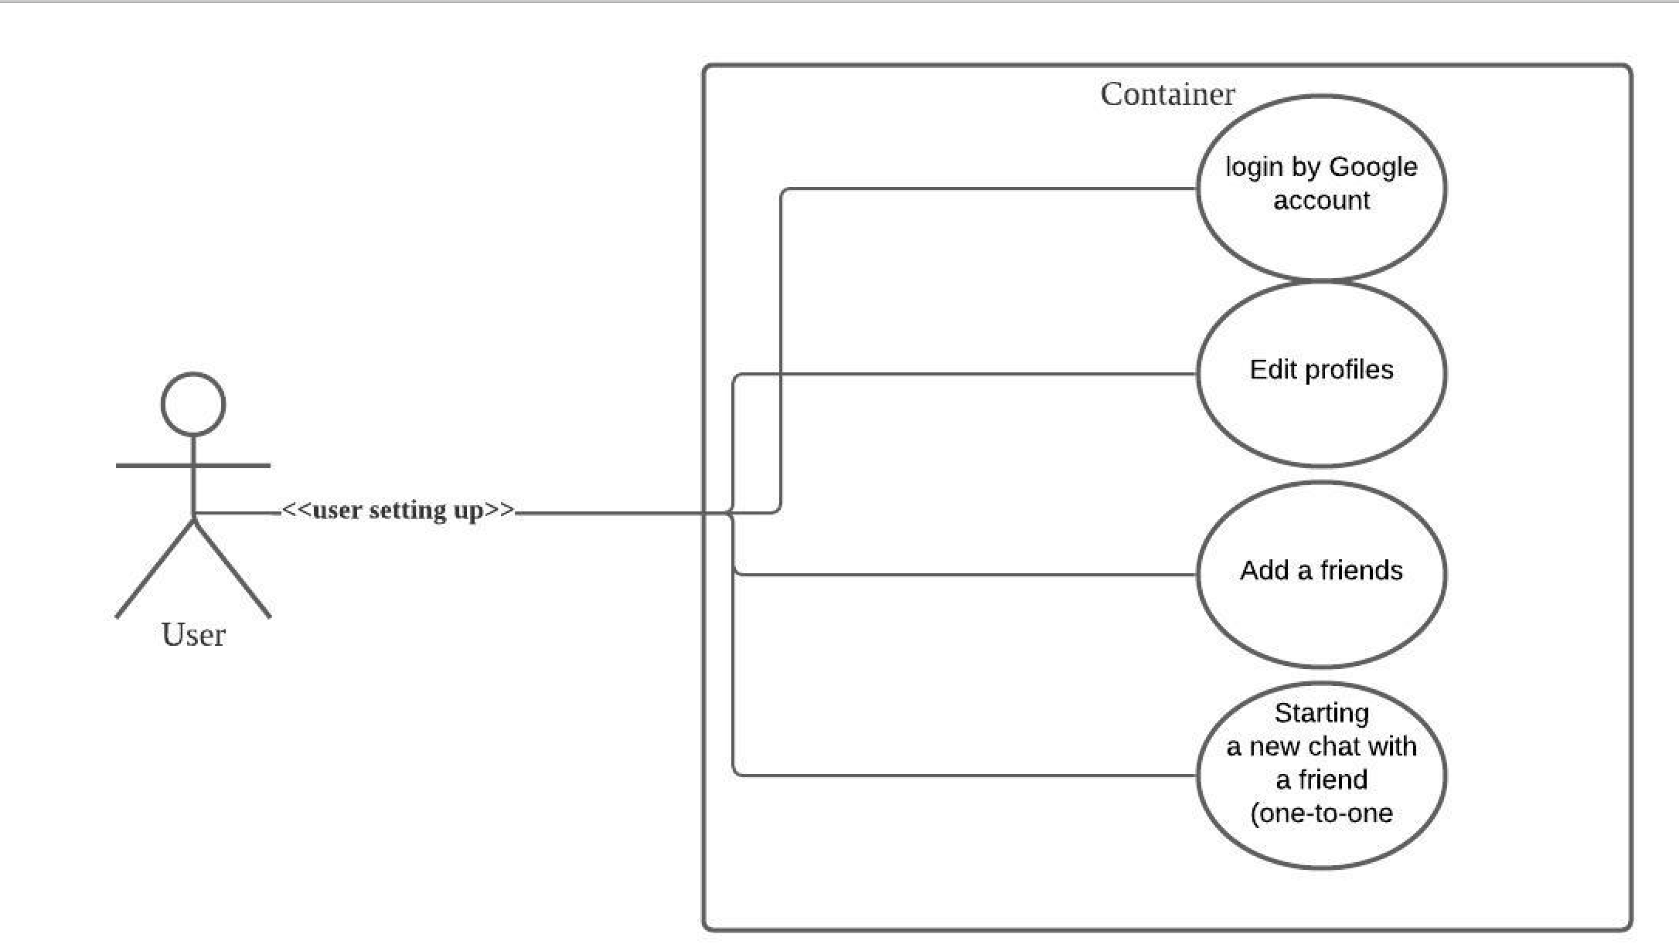

1. Overall user stories:
   1. **Essential Features (the core features that you definitely need to finish):**
2. As a user, I want to send a message to others, so that I can have a private chat with my friend. (10 hours)
3. As a user, I want to send pictures to others, so that I can share my beautiful pictures with my friend. (5 hours)
4. As a user, I want to login into the application with my social media account, so that this will make me more comfortable using this application. (10 hours)
5. As a user, I want to create a chat group of my close friends, so that I can have my close friends discussion. (20 hours)
6. As a user, I want to send a file or location to my friend, so that I can share important files or locations for meeting up.(8 hours)
7. As a user, I want to invite other friends to my current chatroom, so that I can carry on my topics when my friends.(8 hours)
8. As a user, I want to receive a notification when my friends message me, so that I can reply to them instantly.(3 hours)
9. As a user, I want to add my friends with QR code, so that I can have my friends in contact list and build closer relationships within the application.(10 hours)
   1. **Desirable Features (the nice features that you really want to have too):**
10. As a user, I want to have a SMS Authentication, so that I can ensure more security.(8 hours)
11. As a user, I want a Google Translate in the chat, so that I can understand my friends who are foreigners.(9 hours)
12. As a user, I want to see a feed or story of my friends that they are sharing, so that I can know what they are interested in.(20 hours)
13. As a user, I want to follow my friends, so that they can follow me back and see my feed. (10 hours)
14. As a user, I want to have status, so that my friends will know that I am available or away. (AIM style away message).(10 hours)
    1. **Optional Features (additional cool features that you want to have if there is time):**
15. As a user, I want to send stickers to the chat.(8 hours)
16. As a user, I want to have video screen sharing on mobile.(20 hours)
17. As a user, I want to have my own profile.(20 hours)
18. As a user, I want to backup my history chat (10 hours)
    1. **Nonfunctional Requirements**
19. As a client, I want to track which features users use the most by adding Analytics. (15 hours)
20. As developers, I want to set up automation building and deployment, so that program will reduce failures and bugs. (20 hours)
21. As testers, I want to add performance monitoring in the application, so that I will know and predict the application will be a good experience for users.(30 hours)
22. As a security leader, I want to add encryption to both android and backend. (30 hours)
23. As a security leader, I want to have end to end encryption for my correspondence, so that I can ensure that users’ messages are personal and private to them.(30 hours)

3. Essential features in user case diagram:

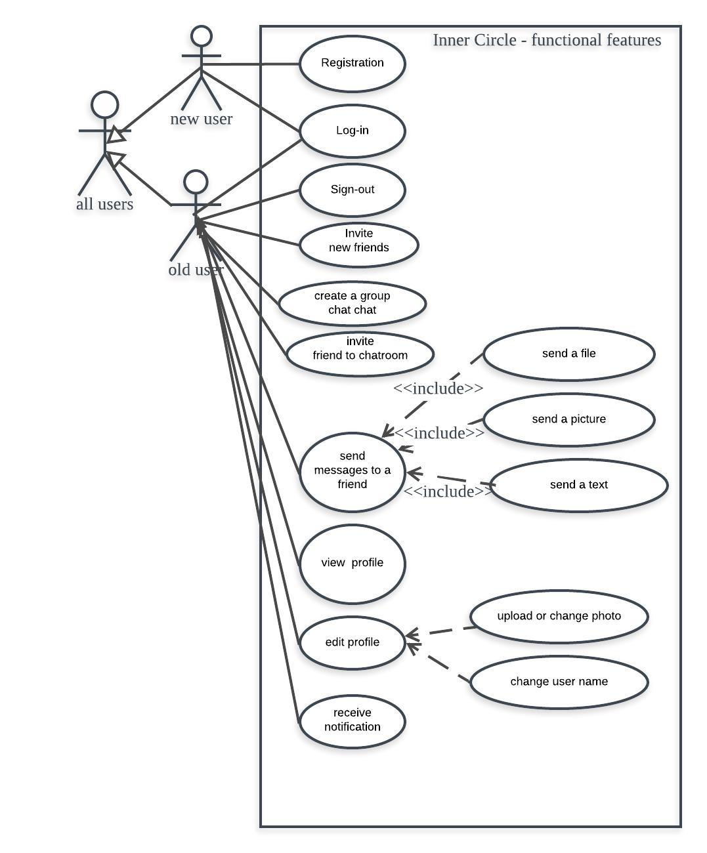

User stories we finished in three iteration:

1. As a user, I want to have authorization with social media accounts, so that I can ensure my security and my comfort using the Inner Circle application.
2. As a user, I want to start a new conversation by being able to initiate a new chat window with a newly friend using the Inner Circle application
3. As a user, I want to add/remove/change my profile picture or my user name
4. As a user, I want to search a specific friend by name, and then send them a message or view their profile.

Story points estimation and actually used:

1. authorization
   1. Estimation: 5 points - 25 hours
   2. Actually used: 23 hours
2. add/remove/change my profile
   1. Estimation: 3 points - 15 hours
   2. Actually used: 27 hours
3. search a specific friend
   1. Estimation: 3 points - 15 hours
   2. Actually used: 25 hours
4. start a new conversation
   1. Estimation: 5 points - 25 hours
   2. Actually used: 23 hours